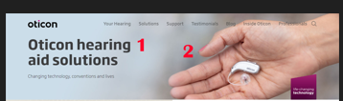

Number# 1:

Otex Hearing Care Solutions

Official Distributor of Oticon in UAE

Number# 2:

We can keep the same picture for now

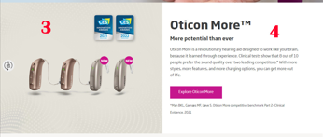

Number# 3: 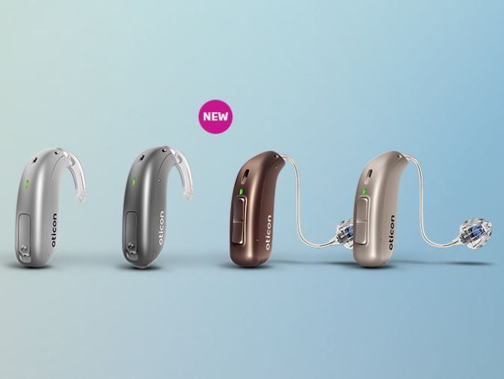

Number#4:

Oticon Zircon creates a seamless experience to help you enjoy today’s connected world. With Oticon Zircon, you also get a wide range of connectivity options for a high-quality listening experience in everyday situations so you can go through your day with more confidence and convenience.

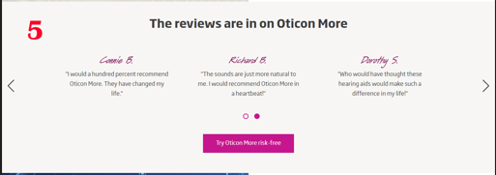

Number# 5:

We don’t have Reviews for now /Can we put instead something else or it should be reviews only?

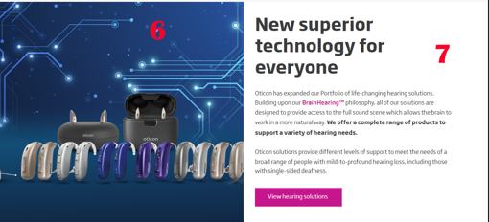

Number# 6:

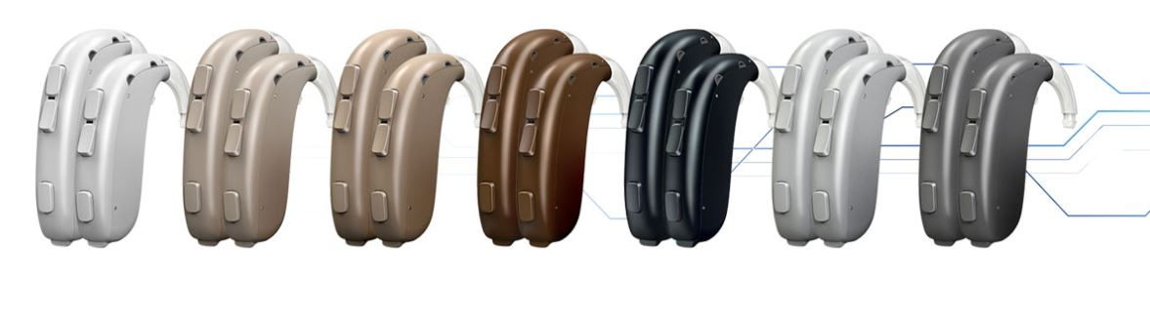

Number# 7:

Introducing Oticon Xceed, the world’s most powerful hearing aid with 146 dB SPL and 87 dB full-on-gain. * Powered by the Velox S™ platform, and featuring BrainHearing™ technology, Oticon Xceed provides more access to speech than ever before for your patients with severe-to-profound hearing loss.

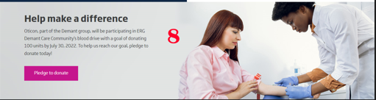

Number# 8:

Opn S takes the open sound experience to the next level, offering more flexibility for you and more choices for your patients. Powered by the Velox S™ platform, Opn S allows patients to enjoy speech understanding on par with normal hearing. *

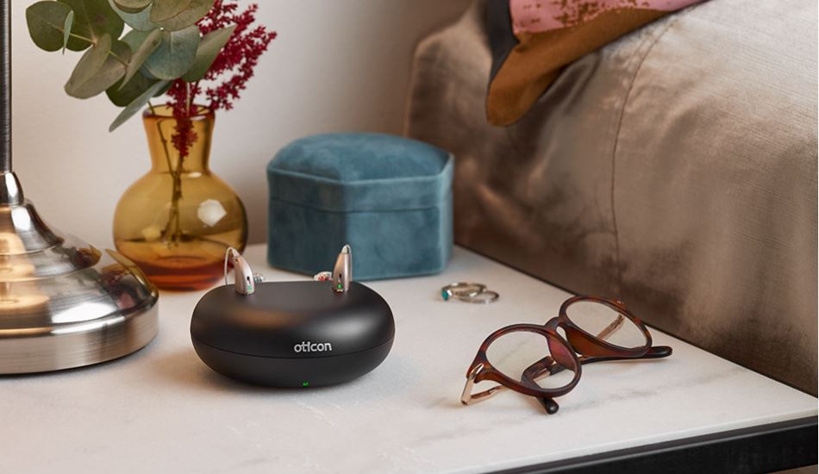

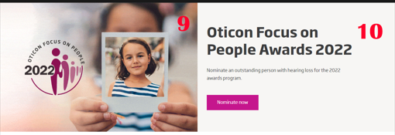

Number# 9:

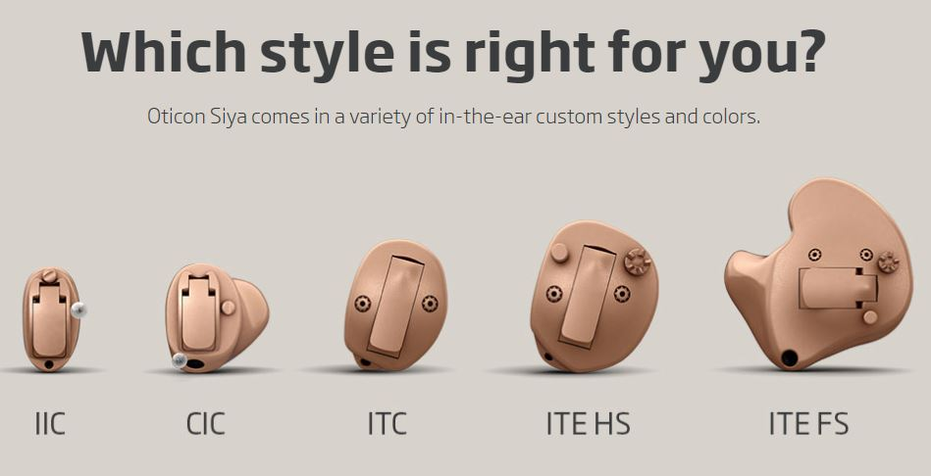

Number# 10:

Oticon Siya in-the-ear hearing aids capture and amplify the natural, rich details of sounds. They help improve your speech understanding, so you can experience the joy of everyday life.  
  
**Oticon Siya highlights:**

* Superb sound quality
* Easy wireless connectivity*
* Effective noise reduction
* A choice of five discreet styles

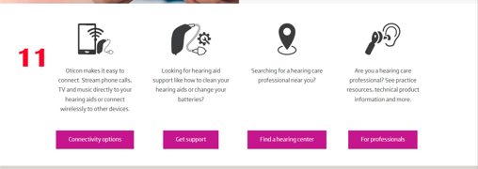

Number# 11:

Keep the same

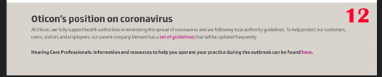

Number# 12:

**Otex Mission**

OTEX guarantees authentic product distribution in United Arab Emirates, being the main distributor and brand carrier of Oticon. We put a lot of efforts in delivering the best to meet the individual requirement of our customers. Our first priority is customer satisfaction and long-lasting relationships.

With OTEX, we guarantee a 100% customer satisfaction with assurance of high-quality and authentic product distribution in UAE.

Our Social Media Links:

Otex Facebook: will share it shortly

Otex Instagram:

<https://www.instagram.com/otexhearingsolutions>

Otex Linkedin:

<https://www.linkedin.com/in/otex-oticon-8008ba8a>

Our Clients :

* Sheikh ShakhbootHospital
* Dubai Health Authority
* MinistryofHealth
* American Hospital
* Zayed MilitaryHospital
* Mediclinic
* EmiratesHospital
* Mediclinic
* Al GarhoudHospital
* HealthbayPolyclinic
* IranianHospital
* Prime group of Clinics andHospitals
* Al Zahra HospitalDubai
* Medcare
* Ear CareClinic
* Saudi-GermanHospital
* Dubai-London SpecialtyClinic
* Al Amal MedicalCenter
* Polymedic MedicalCenter
* Al Manara MedicalCenter
* AL Madar MedicalCenter
* Sharjah City for HumanitarianServices
* Thumbay HospitalAjman
* Arab Doctors MedicalCenter
* Al Zahra HospitalSharjah
* Jordan Speech and Rehabilitation Center AlAin
* Aster MedicalClinics
* Al NoorPolyclinic
* ArmadaHospital
* PrimeMedical Centres
* NMC
* Others…

Our Address:

<https://g.page/OtexHearingAids?share>

B3704, Latifa Tower Sheikh Zayed Road Dubai

Landline: 04-3547887